👋 Hi everyone, Imran here.
Welcome to Edition #29 of a newsletter that 15,000+ people around the world actually look forward to reading.
We’re living through a strange moment: the internet is drowning in polished AI noise that says nothing.
This isn’t that. You’ll find raw, honest, human insight here, the kind that challenges how you think, not just what you know. Thanks for being part of a community that still values depth over volume.
🎓 Want to up skill in AI?
- Join the next cohort of my Agent Engineering Bootcamp (Developers Edition) April 8
- Watch the free 4-session Agent Bootcamp playlist on YouTube

Knowledge Graphs vs Naive RAG: When to Use Each
Enterprise AI teams face a tough choice when building retrieval-augmented generation systems: knowledge graphs or naive RAG? Your decision will affect system performance, development speed, and costs.
Knowledge graphs and Retrieval-Augmented Generation (RAG) take different approaches to improving AI systems. Each works better for specific situations. Understanding when to use knowledge graphs versus naive RAG will improve your AI application's performance and accuracy.
Knowledge graphs provide structured relationship intelligence that goes beyond naive RAG's simple document retrieval. These systems map complex relationships between entities. Your AI can then understand context, hierarchies, and semantic connections across data. Naive RAG works well when you need rapid deployment. You get quick implementation for straightforward question-answering tasks. This approach works best for organizations needing immediate results without complex data modeling.
Knowledge graph technology transforms LLM inference quality by adding structured knowledge representations. Your AI systems get validated relationships and factual consistency. This reduces hallucinations and improves response accuracy. The two approaches have different implementation costs. Naive RAG requires minimal setup while knowledge graphs demand substantial upfront investment in data modeling and ontology design.
This analysis examines the technical foundations of both approaches. You'll get detailed guidance for selecting the optimal strategy based on your specific requirements, available resources, and desired system sophistication.
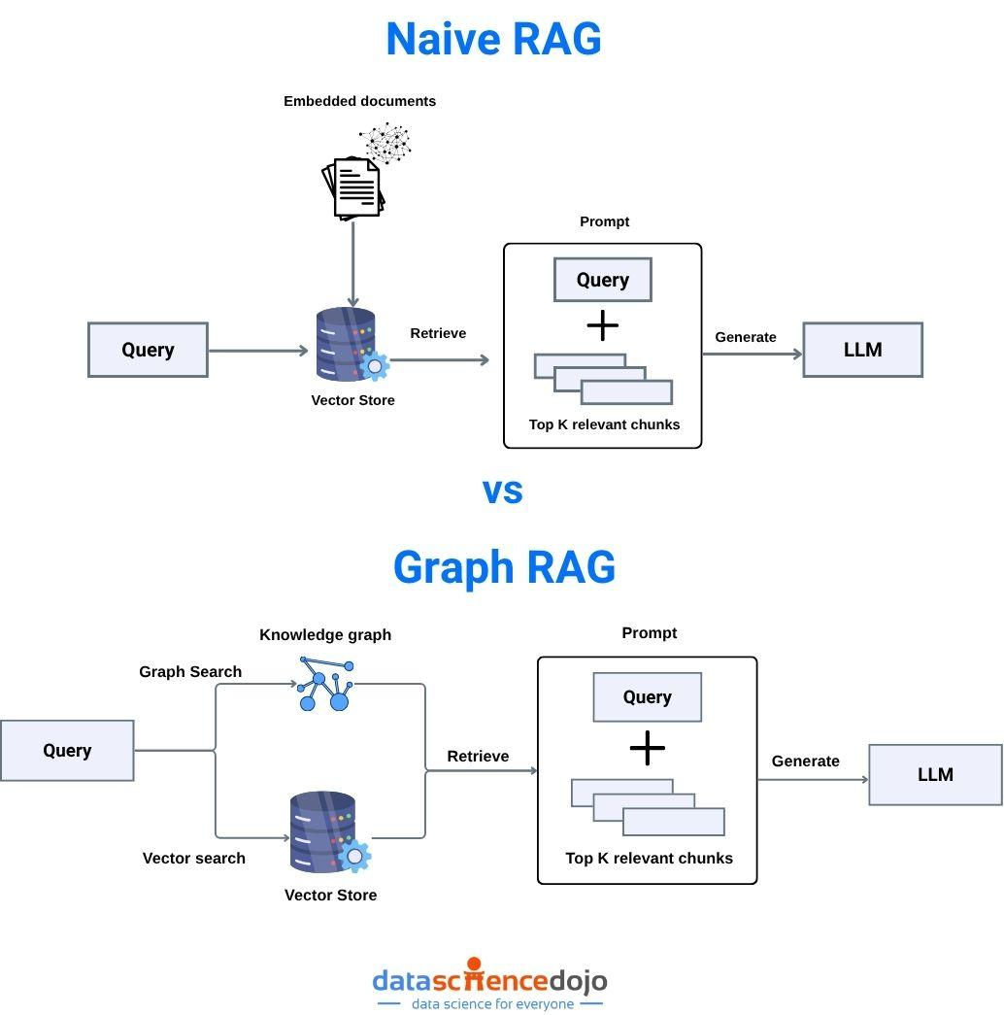
Source : https://datasciencedojo.com/blog/graph-rag-vs-rag/

Understanding Knowledge Graphs in AI Systems

What Knowledge Graph Technology Includes
Knowledge graphs represent structured data as interconnected networks of entities, relationships, and attributes. These form the foundation for advanced AI reasoning. The systems organize information using nodes (entities) connected by edges (relationships). This creates semantic networks in machine-readable formats.
The core architecture has three fundamental components:
- Entities (people, places, concepts)
- Relationships (connections between entities)
- Properties (attributes describing entities)
This triple-based structure lets AI systems perform complex reasoning tasks. Your system traverses relationship paths and infers new knowledge from existing connections.
Modern knowledge graphs use ontologies. These are formal specifications that define entity types, relationship categories, and semantic rules governing the knowledge domain. The ontological frameworks ensure consistency, enable automated reasoning, and support sophisticated query capabilities beyond traditional database operations.
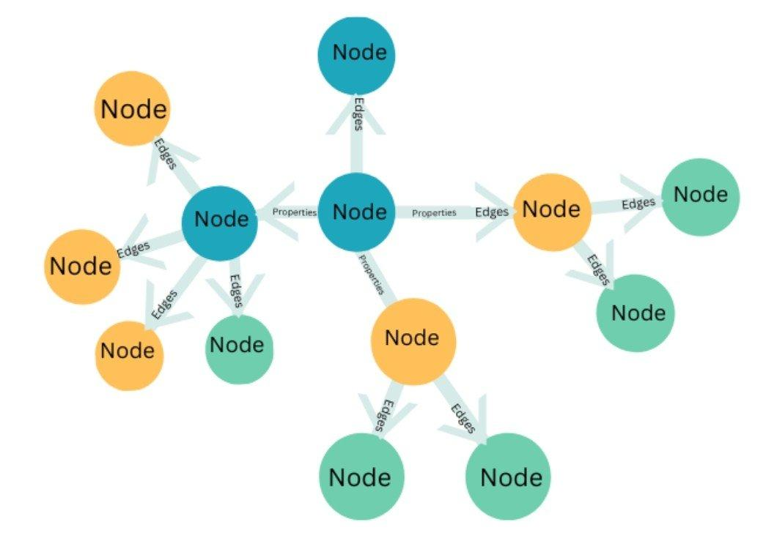
Source: https://www.graphlit.com/blog/introduction-to-knowledge-graphs

How Knowledge Graphs Work With AI
Knowledge graphs integrate with large language models through multiple pathways. These enhance both retrieval accuracy and reasoning. The primary approach embeds knowledge graph entities and relationships into vector spaces compatible with transformer architectures. Your LLMs access structured knowledge during inference processes.
Graph neural networks (GNNs) translate knowledge graph structures into representations suitable for transformer consumption. These networks propagate information across graph edges. They aggregate contextual signals from entity neighborhoods to generate enriched embeddings. The embeddings capture both local and global structural information.
Advanced architectures implement knowledge graph grounding mechanisms. These anchor LLM responses to verified factual relationships. This grounding process reduces hallucination rates by constraining generation processes to align with established knowledge graph facts. Your output stays consistent with validated information sources.
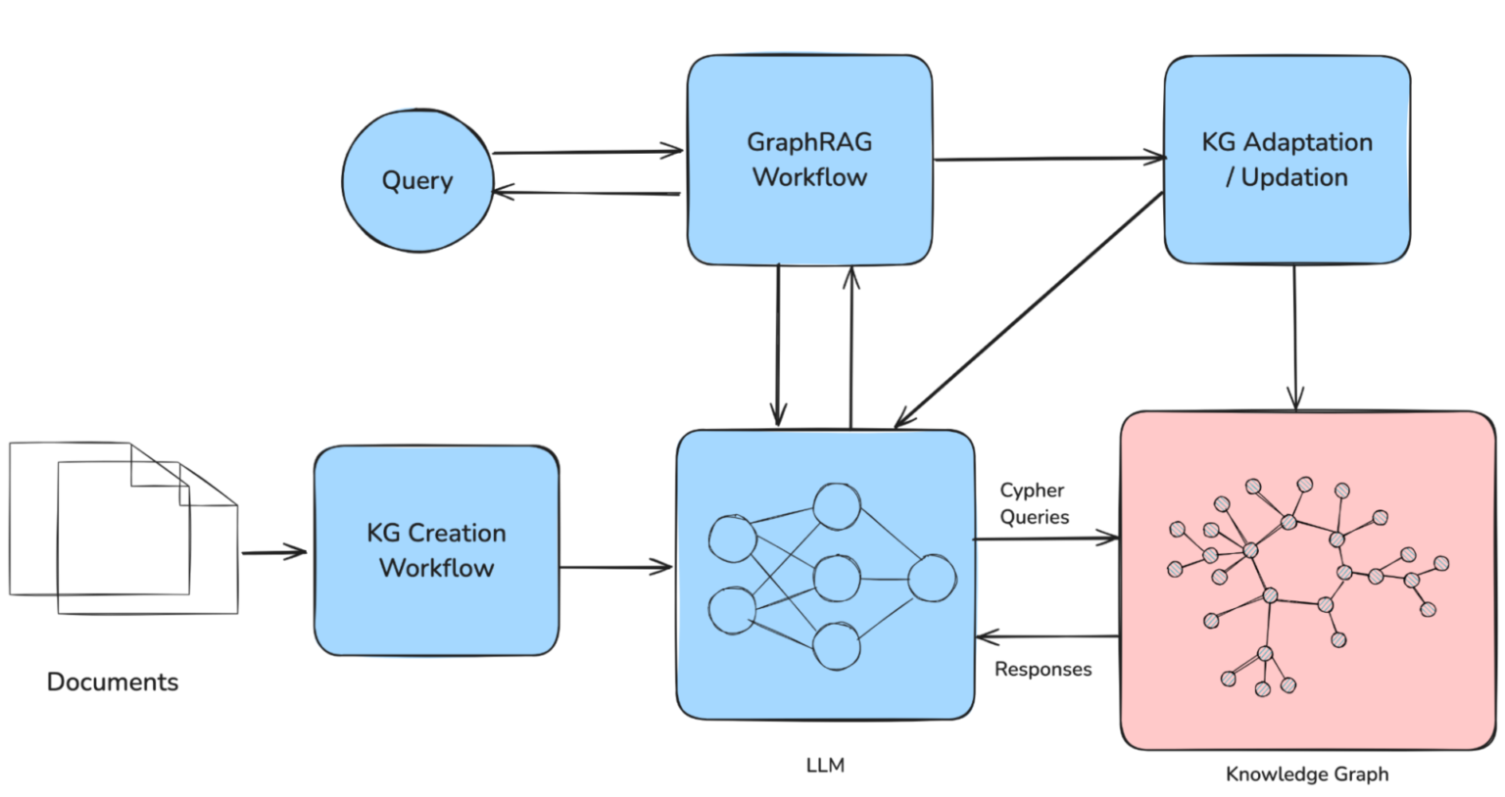
Source: https://www.falkordb.com/blog/knowledge-graph-llm/

Building Graph Data Models for AI
Good graph data modeling requires careful consideration of entity granularity, relationship hierarchies, and temporal dynamics. These factors influence AI system performance. The modeling process begins with domain analysis. You identify key entity types, relationship patterns, and semantic constraints that govern the knowledge space.
Entity resolution presents a critical modeling challenge. Real-world data sources often contain duplicate or conflicting entity references. Advanced modeling frameworks implement entity linking algorithms. These disambiguate references using contextual signals while maintaining knowledge graph consistency across diverse data sources.
Temporal modeling adds complexity by tracking entity state changes and relationship evolution over time. These temporal dimensions enable your AI to reason about historical contexts, predict future states, and maintain consistency across time-dependent queries.

Naive RAG Systems: Fundamentals and Architecture

How Retrieval-Augmented Generation Works
Naive RAG systems operate on a straightforward principle: retrieve relevant documents from external knowledge sources and provide them as context for language model generation. This approach addresses the fundamental limitation of pre-trained LLMs. They have knowledge cutoff dates and no access to real-time information. RAG augments generation with dynamically retrieved content.
The retrieval process employs dense vector similarity search. Embedding models encode both queries and documents into high-dimensional vector spaces. Similarity calculations identify the most relevant documents. These are then concatenated with user queries to form extended prompts for language model processing.
This architecture provides immediate benefits:
- Access to current information
- Reduced hallucination rates for factual queries
- Ability to incorporate domain-specific knowledge without expensive model retraining
Naive RAG faces significant limitations in handling complex reasoning tasks. These require understanding relationships between retrieved documents.
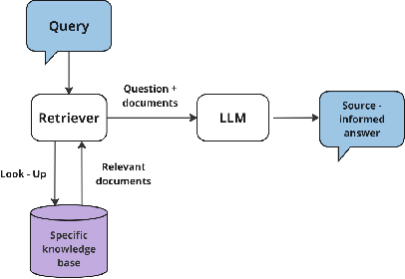
Source: https://www.researchgate.net/figure/Typical-naive-RAG-architecture_fig1_390101783

How to Implement Naive RAG
Standard naive RAG implementations follow a three-stage pipeline: document preprocessing, retrieval execution, and generation synthesis. Document preprocessing involves chunking text into semantically coherent segments. You generate embeddings for each chunk and store these representations in vector databases for efficient similarity search.
The retrieval stage executes similarity searches against stored embeddings. The system returns the top-k most similar document chunks based on cosine similarity or other distance metrics. Retrieved chunks are ranked by relevance scores and concatenated to form context windows within language model token limits.
Generation synthesis combines retrieved context with user queries using crafted prompts. These instruct the language model to generate responses based on provided information. This stage often includes instructions to cite sources, acknowledge uncertainty when information is insufficient, and maintain consistency with retrieved content.
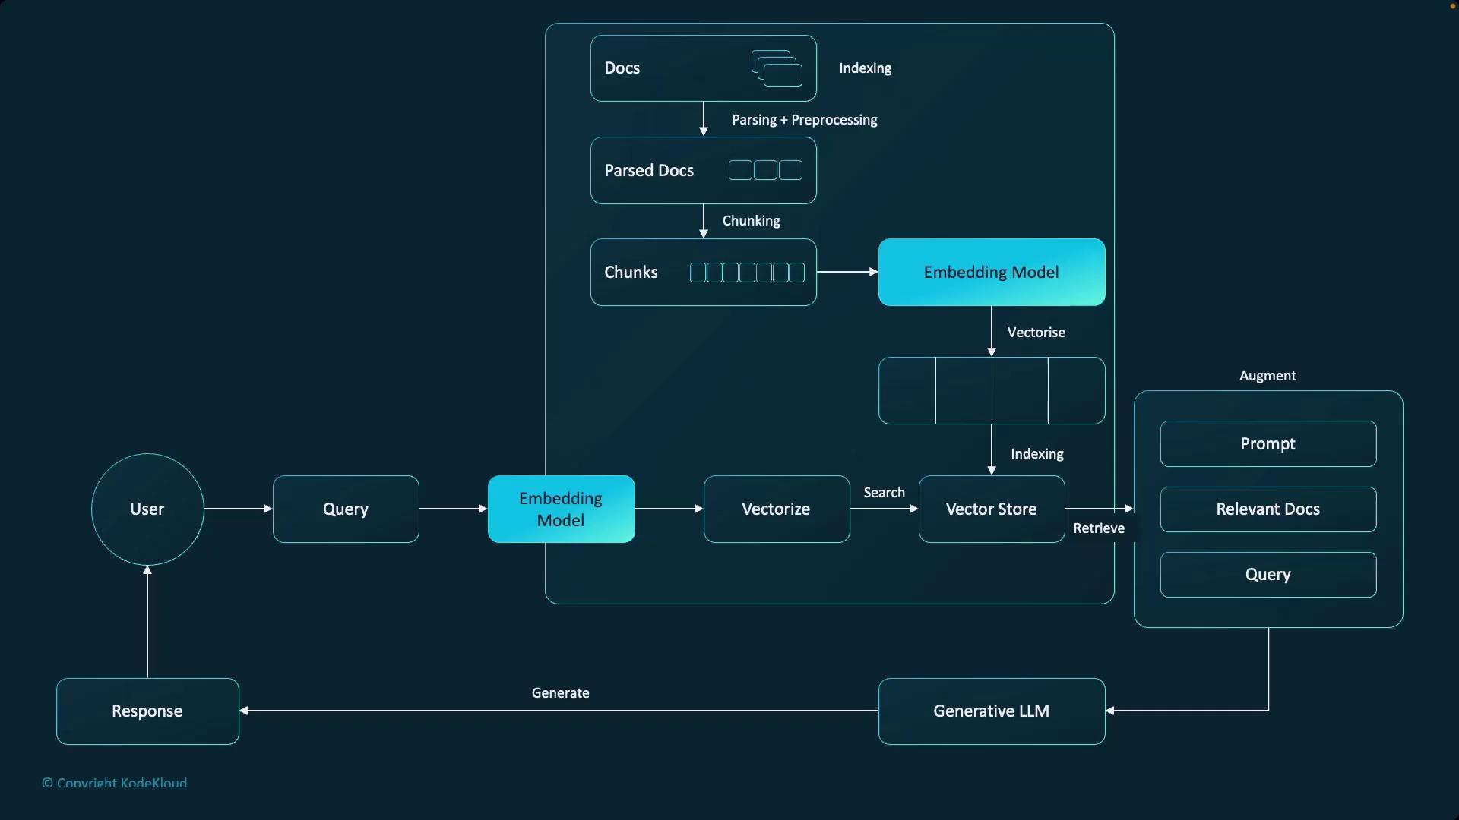
Source: https://notes.kodekloud.com/docs/Generative-AI-in-Practice-Advanced-Insights-and-Operations/Retrieval-Augmented-Generation-RAG/Naive-RAG/page

Where Traditional RAG Falls Short
Naive RAG systems struggle with multi-hop reasoning tasks. These require connecting information across multiple documents or understanding complex relationships between entities. The simple similarity-based retrieval mechanism cannot capture semantic dependencies that span document boundaries. This limits system capability for sophisticated analytical tasks.
Context window constraints present another significant limitation. Transformer architectures impose token limits that restrict the amount of retrieved information available during generation. This forces your system to make difficult trade-offs between context breadth and depth. You might exclude relevant information that could improve response quality.
Document chunking strategies introduce artificial boundaries. These fragment coherent information, leading to incomplete context retrieval and degraded generation quality. These chunking decisions significantly impact system performance but lack principled optimization frameworks that balance chunk size, semantic coherence, and retrieval effectiveness.
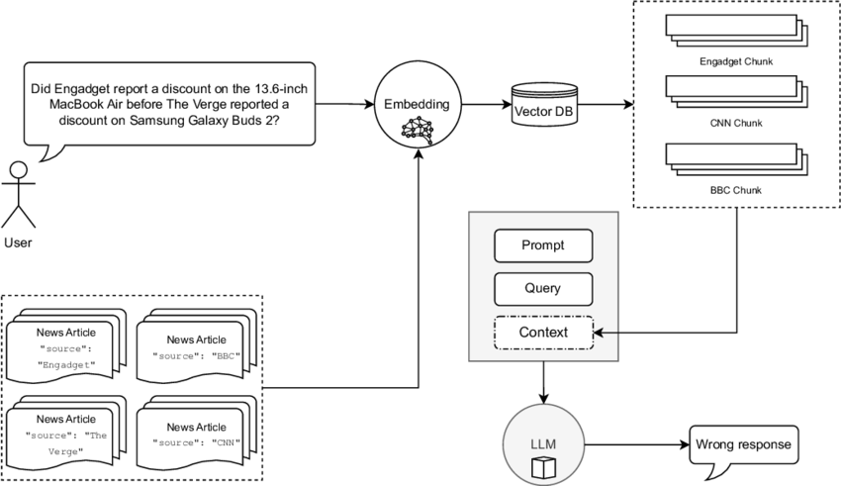
Source: https://www.researchgate.net/figure/A-naive-RAG-implementation-for-MultiHop-RAG-queries-RAG-selects-chunks-from-articles-not_fig1_381579243

Knowledge Graph Integration with RAG Systems

How Structured Knowledge Improves Retrieval
Knowledge graph integration transforms naive RAG limitations. You get structured pathways for multi-hop reasoning and semantic relationship traversal. Instead of relying solely on document similarity, graph-enhanced systems navigate relationship networks to discover relevant information through logical inference processes.
This integration enables sophisticated query processing. Your system combines entity recognition, relationship resolution, and path-based retrieval to gather comprehensive context for generation tasks. The system first identifies entities mentioned in user queries, locates corresponding nodes in the knowledge graph, and explores relationship neighborhoods to discover relevant connected information.
Knowledge graphs enable precise semantic filtering. This improves retrieval precision compared to naive similarity-based approaches. By understanding entity types, relationship semantics, and domain constraints, graph-enhanced systems eliminate irrelevant results and focus retrieval on information directly pertinent to user queries.
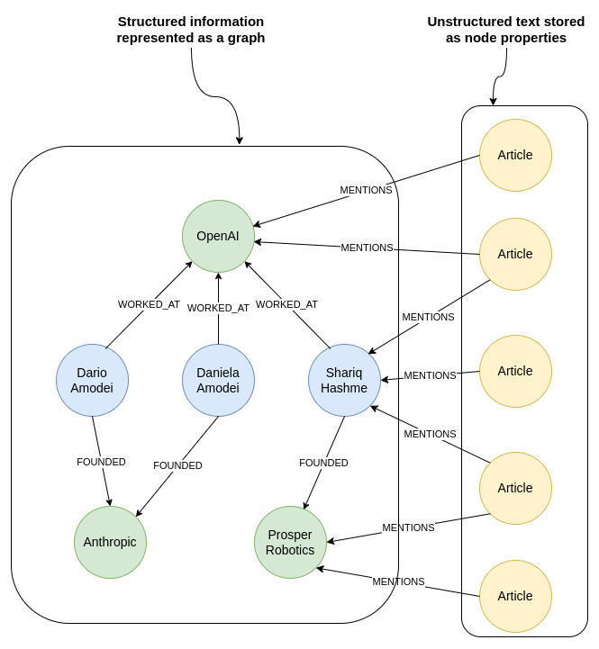
Source: https://neo4j.com/blog/genai/knowledge-graph-llm-multi-hop-reasoning/

Building Hybrid Architectures
Advanced implementations combine knowledge graph capabilities with traditional document retrieval. These hybrid architectures leverage both structured and unstructured information sources. The systems maintain separate retrieval pathways for graph-based entity information and document-based contextual content. Results merge during generation processes.
The hybrid approach addresses complementary strengths. Knowledge graphs excel at factual accuracy and relationship reasoning. Document retrieval provides rich contextual information and detailed explanations. Sophisticated fusion mechanisms determine optimal combinations of graph-derived facts and document-based context for specific query types.
Implementation strategies include multi-stage retrieval pipelines. These first consult knowledge graphs for entity disambiguation and relationship identification. Then you use this structured information to guide more targeted document retrieval. This approach significantly improves both precision and recall compared to purely naive or purely graph-based systems.
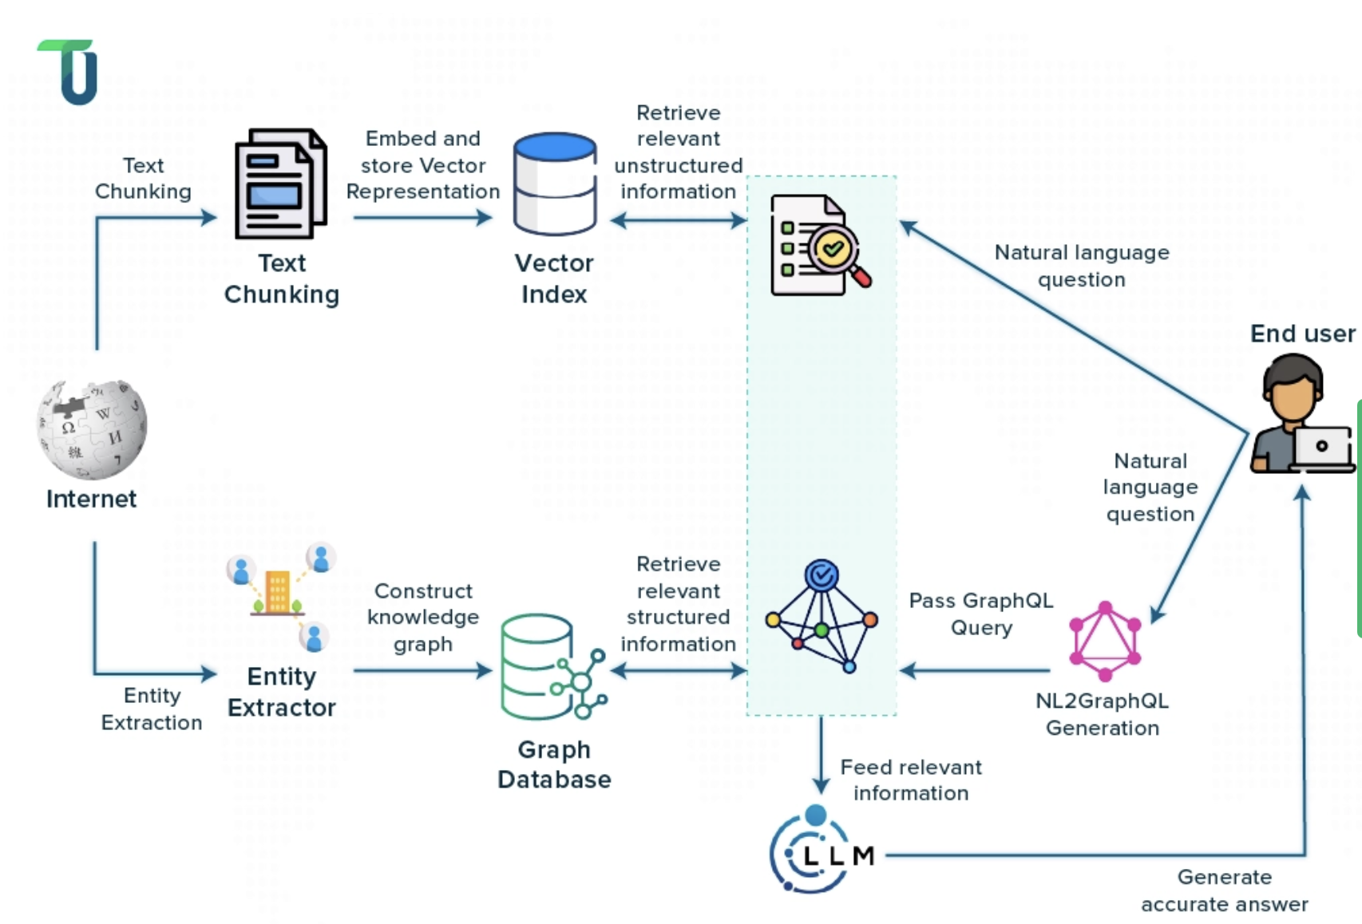
Source: https://www.tenupsoft.com/blog/boosting-ai-with-graph-and-vector-databases-in-rag-system.html

What You Need to Know About Implementation
Successful knowledge graph integration requires careful attention to scalability, latency, and maintenance. These impact production deployment viability. Graph traversal algorithms must be optimized for real-time query processing while maintaining accuracy across large-scale knowledge bases with millions of entities and relationships.
Embedding alignment represents a critical technical challenge. Knowledge graph entity embeddings must be compatible with document embedding spaces to enable effective similarity calculations. Advanced implementations use shared embedding spaces or transformation layers that bridge between graph and document representations.
Incremental update mechanisms ensure knowledge graph currency without requiring complete system rebuilds. These update processes must handle entity additions, relationship modifications, and conflict resolution while maintaining system availability and consistency across distributed deployment environments.
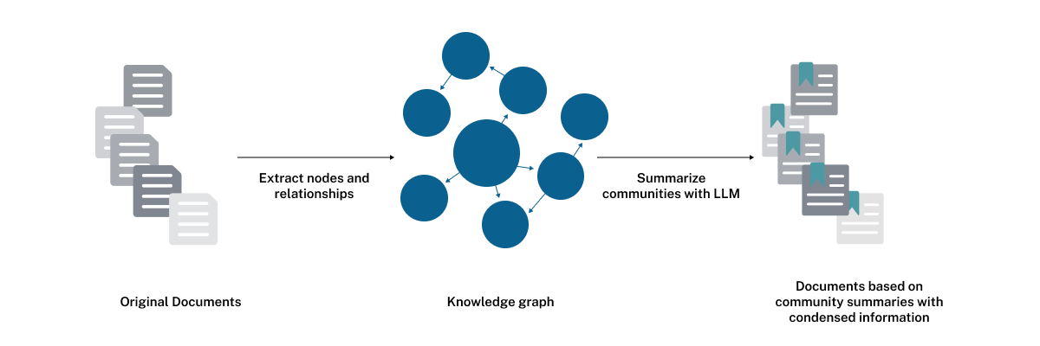
Source: https://neo4j.com/blog/developer/global-graphrag-neo4j-langchain/

Use Cases and Performance Comparison

When Knowledge Graphs Work Best
Knowledge graphs demonstrate superior performance in applications requiring precise entity disambiguation, multi-entity relationship analysis, and complex reasoning across structured domains. Financial services applications benefit significantly from knowledge graph capabilities when analyzing corporate hierarchies, ownership relationships, and regulatory compliance requirements spanning multiple entities and jurisdictions.
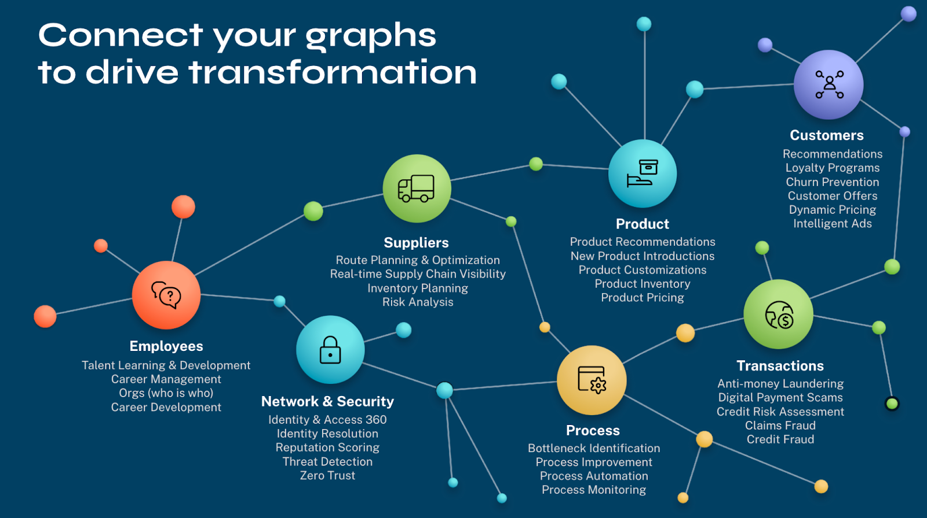
Source: https://neo4j.com/blog/graph-database/graph-database-use-cases/

Investment Risk Assessment Platform
A major investment firm implemented a knowledge graph-enhanced RAG system to analyze portfolio risk across complex corporate structures. The system mapped relationships between companies, subsidiaries, executives, and market sectors. Analysts could identify hidden risk concentrations. By understanding ownership networks and board connections, the platform reduced assessment time by 65% while identifying 23% more potential risk factors compared to their previous naive RAG system. The implementation saved approximately $2.3M annually in analyst time while improving investment decision accuracy.
Healthcare and biomedical applications represent another domain where knowledge graphs shine. Drug discovery workflows require understanding complex molecular relationships, protein interactions, and therapeutic pathways. Naive RAG systems cannot effectively capture these through simple document similarity.
Legal and regulatory analysis applications leverage knowledge graph capabilities for case law analysis, statutory interpretation, and precedent tracking. These require understanding hierarchical legal relationships and citation networks. Applications benefit from the precise relationship modeling and logical inference capabilities that knowledge graphs provide.

When Naive RAG Works Best
Naive RAG systems excel in scenarios requiring rapid deployment, straightforward question-answering, and content summarization tasks where relationship complexity remains limited. Customer support applications often benefit from naive RAG approaches when addressing product documentation queries, troubleshooting procedures, and FAQ responses. These don't require complex reasoning.
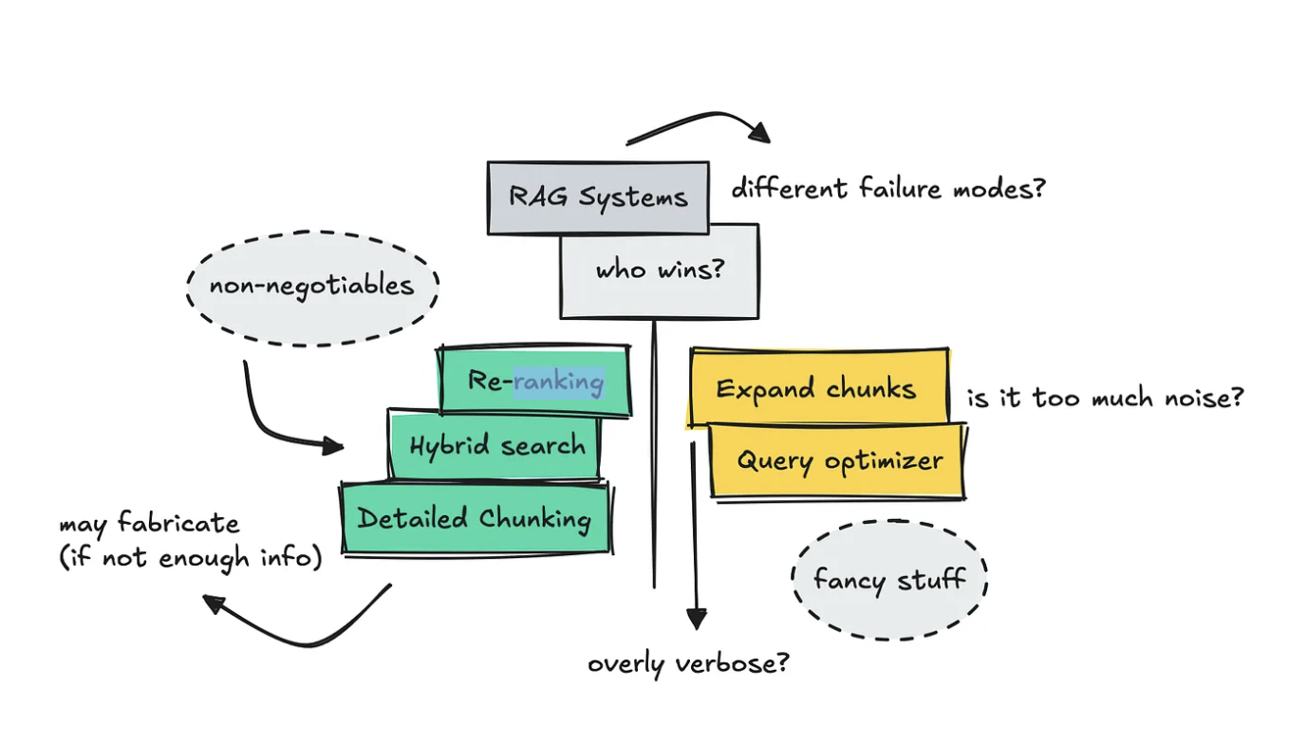
Source: https://medium.com/data-science-collective/testing-a-naive-rag-pipeline-vs-an-advanced-one-cb34a8cf1b5e

Technical Documentation Assistant
A software company deployed a naive RAG system to assist customer support teams with technical documentation queries. The system indexed 15,000 documentation pages and provided instant answers to customer questions about product features, installation procedures, and troubleshooting steps. Implementation took only three weeks and reduced average query resolution time from 45 minutes to 8 minutes, while maintaining 94% accuracy for factual questions. The system processed 12,000 queries monthly and reduced support ticket volume by 38%.
Content creation and research assistance represent strong use cases for naive RAG systems. This applies when users need access to recent information, diverse perspectives, and detailed explanations. These don't depend on understanding complex entity relationships. Applications prioritize breadth of information access over sophisticated reasoning capabilities.
Educational applications often favor naive RAG approaches for basic information lookup, concept explanation, and study assistance. The primary goal involves accessing relevant information quickly rather than performing complex analytical reasoning across multiple information sources.

How to Measure Performance
Evaluation of knowledge graph versus naive RAG systems requires multidimensional assessment frameworks. You need to capture accuracy, reasoning capability, response quality, and operational efficiency. Traditional metrics like BLEU and ROUGE scores provide limited insight into the sophisticated reasoning capabilities that differentiate these approaches.
Graph-specific evaluation metrics include:
- Relationship accuracy
- Multi-hop reasoning success rates
- Entity disambiguation precision
These metrics assess your system's ability to correctly traverse relationship paths, resolve entity references, and maintain factual consistency across complex queries.
Operational metrics encompass deployment complexity, maintenance overhead, and scalability characteristics. These influence total cost of ownership. These practical considerations often determine system selection despite theoretical performance advantages. This applies in resource-constrained environments or rapid deployment scenarios.
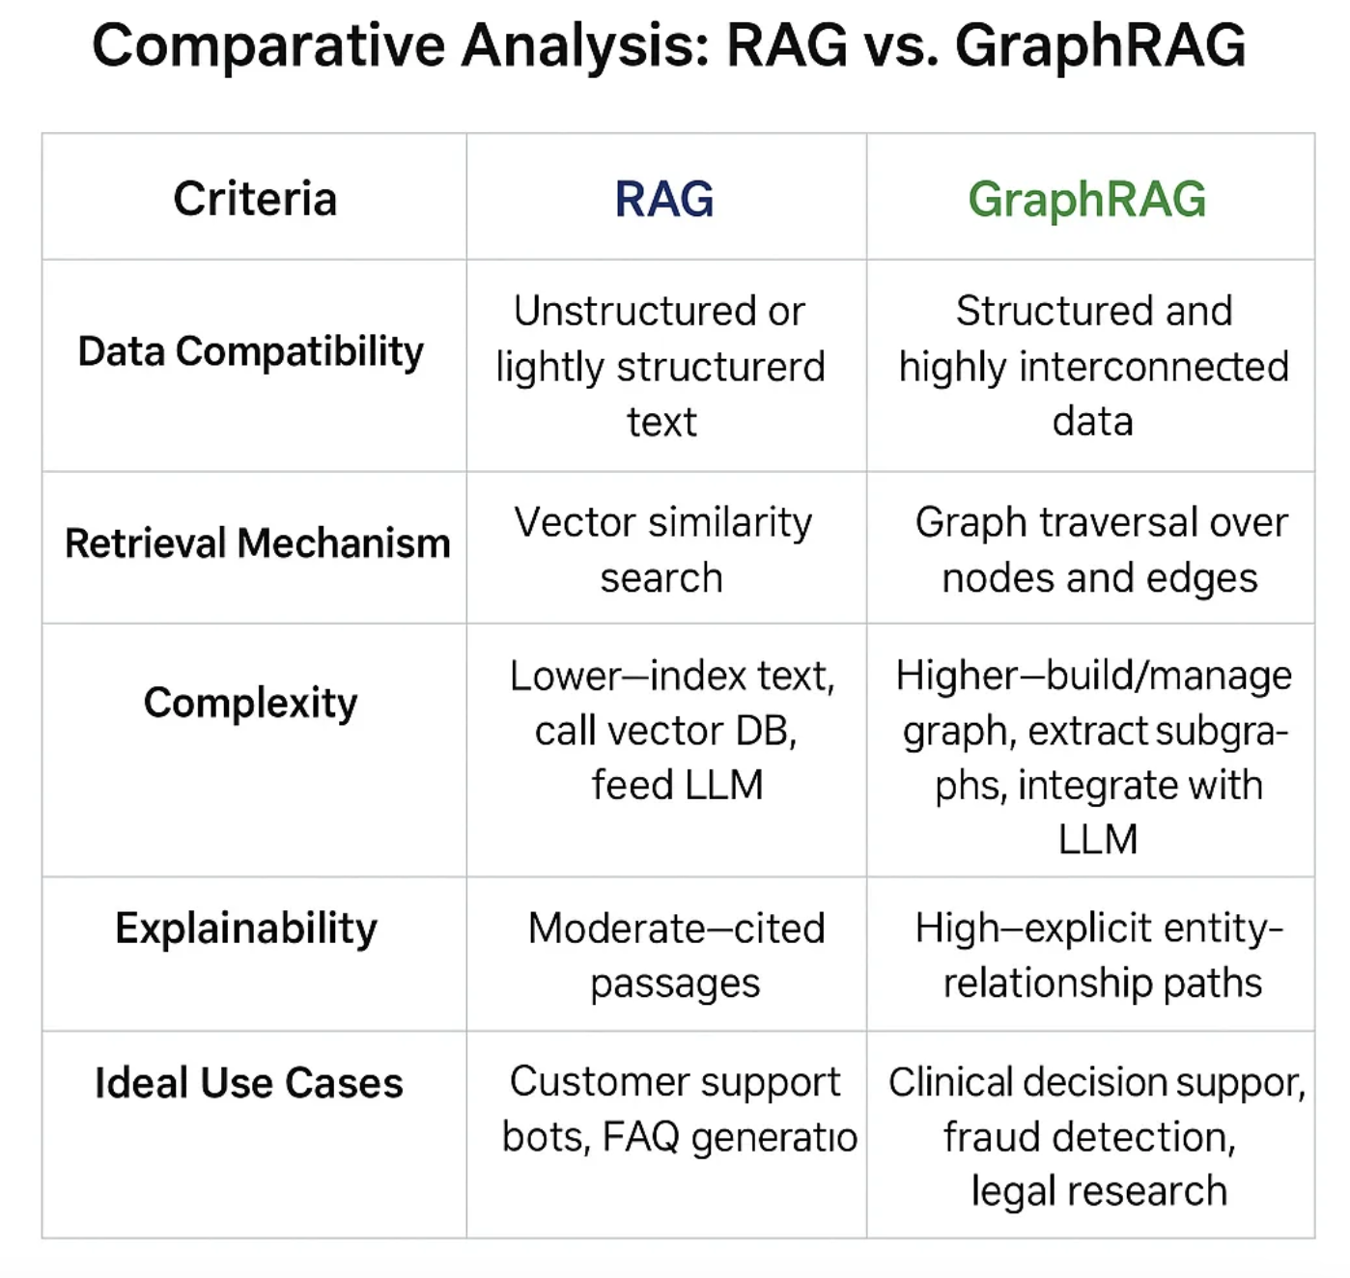
Source: https://prajnaaiwisdom.medium.com/choosing-between-rag-and-graphrag-based-on-data-type-and-structure-9911020501fc

Implementation Strategy and Decision Framework

How to Analyze Costs and Benefits
The decision between knowledge graphs and naive RAG requires comprehensive cost-benefit analysis. This extends beyond initial development investments. You need to include ongoing maintenance, scalability requirements, and opportunity costs associated with delayed deployment timelines.
Knowledge graph implementations require substantial upfront investments in data modeling, ontology design, entity resolution, and relationship extraction processes. These costs compound when considering ongoing maintenance requirements for knowledge base updates, quality assurance, and schema evolution as domain requirements change.
Naive RAG systems offer significantly lower initial implementation costs and faster time-to-value delivery. This makes them attractive for proof-of-concept projects and organizations with limited AI development resources. These systems may require substantial redesign when requirements evolve to demand more sophisticated reasoning capabilities.
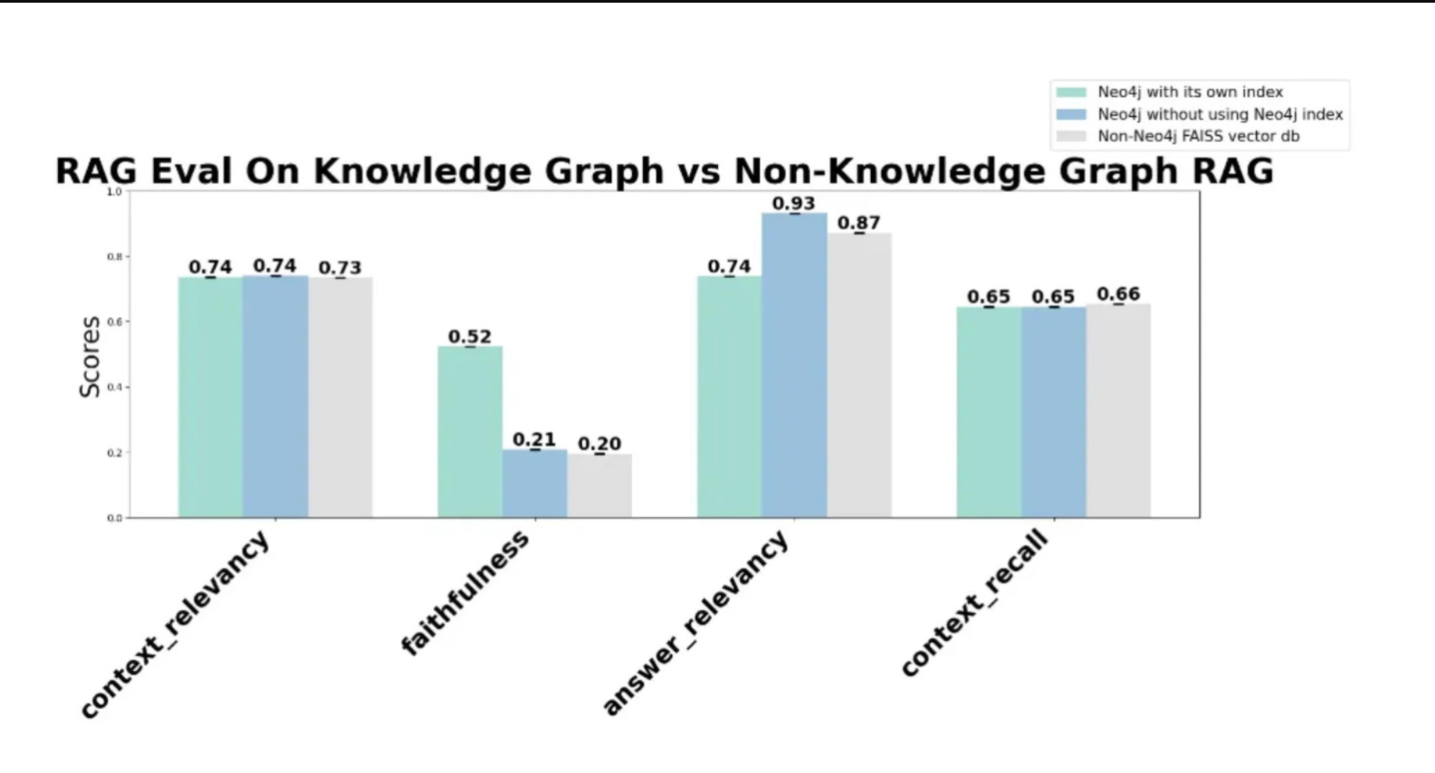
Source: https://www.jonathanbennion.info/p/graphrag-analysis-part-1-how-indexing

Infrastructure You'll Need
Knowledge graph deployments require specialized infrastructure components:
- Graph databases
- Reasoning engines
- Entity linking systems
These demand specific technical expertise and operational overhead. The systems benefit from dedicated hardware optimized for graph traversal operations and memory-intensive reasoning processes.
The infrastructure complexity extends to monitoring, backup, and disaster recovery procedures. These must account for graph-specific data structures and consistency requirements. Traditional database management approaches often prove inadequate for maintaining knowledge graph integrity across distributed deployment environments.
Naive RAG systems leverage more standard infrastructure components:
- Vector databases
- Embedding services
- Traditional text processing pipelines
These align with existing organizational capabilities and operational procedures. This alignment significantly reduces deployment friction and operational complexity.
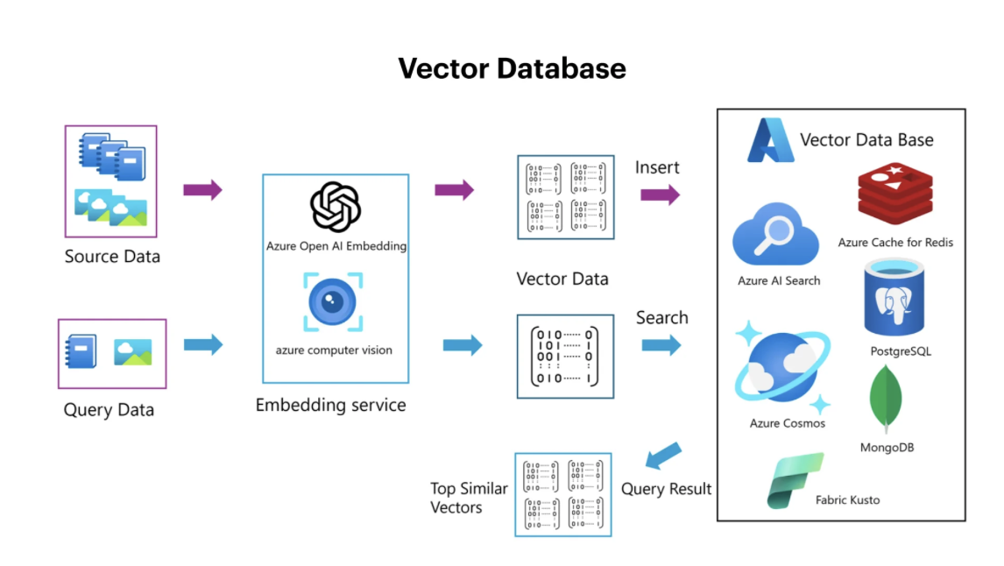
Source: https://www.openxcell.com/blog/vector-database-vs-graph-database/

How to Transition Between Approaches
Organizations often benefit from migration strategies that begin with naive RAG implementations. You gradually incorporate knowledge graph capabilities as requirements mature and technical capabilities develop. This evolutionary approach allows teams to gain experience with RAG concepts while building toward more sophisticated implementations.
Hybrid architectures provide intermediate solutions. These capture benefits from both approaches without requiring complete commitment to either paradigm. Implementations start with document-based retrieval augmented by simple entity recognition and relationship extraction capabilities.
Advanced migration strategies implement modular architectures. These support incremental knowledge graph integration without disrupting existing naive RAG capabilities. The approaches enable gradual transition while maintaining system availability and user experience throughout the evolution process.

Advanced Considerations and Future Directions

What's Coming Next for Graph-Enhanced LLM Systems
Recent developments in graph neural networks and transformer architectures are creating new opportunities for tighter integration between knowledge graphs and large language models. Graph-aware attention mechanisms enable transformers to directly process graph structures without requiring intermediate embedding translations.
Multimodal knowledge graphs incorporate text, images, and structured data. These expand the scope of graph-enhanced RAG systems beyond traditional text-based applications. These developments enable more comprehensive AI systems. You can reason across diverse information modalities while maintaining structured relationship understanding.
Foundation models specifically designed for graph reasoning are emerging. These offer pre-trained capabilities that reduce the custom development required for knowledge graph integration. These specialized models promise to lower implementation barriers while providing superior performance for graph-based reasoning tasks.

Enterprise-Scale Considerations
Enterprise-scale knowledge graph deployments face unique challenges related to data governance, privacy compliance, and integration with existing enterprise systems. These considerations often determine system architecture decisions independent of pure technical performance characteristics.
Federated knowledge graph architectures are emerging to address enterprise requirements for distributed data ownership. You maintain coherent reasoning capabilities across organizational boundaries. These approaches enable knowledge sharing while preserving data sovereignty and access control requirements.
Real-time update capabilities represent critical requirements for enterprise deployments. Knowledge currency directly impacts business operations. Advanced implementations provide near-real-time knowledge graph updates while maintaining consistency and avoiding reasoning disruptions.

How to Ensure Quality
Knowledge graph quality assurance requires sophisticated validation frameworks. These detect inconsistencies, verify relationship accuracy, and maintain ontological coherence across large-scale knowledge bases. The frameworks often incorporate both automated validation rules and human review processes.
Bias detection and mitigation represent critical considerations for both knowledge graph and naive RAG systems. These biases significantly impact AI system fairness and accuracy. Advanced implementations incorporate bias monitoring and correction mechanisms throughout the development and deployment lifecycle.
Continuous learning capabilities enable systems to improve performance through user interaction feedback and automated quality assessment. These mechanisms help maintain system accuracy while adapting to evolving domain requirements and user expectations.

Reflections
Your strategic choice between knowledge graphs and naive RAG systems shapes AI implementation success. You need to carefully evaluate technical requirements, resource constraints, and long-term organizational objectives. Knowledge graphs provide structured relationship intelligence. This enables sophisticated multi-hop reasoning, entity disambiguation, and logical inference capabilities. These systems excel when applications demand factual consistency, relationship understanding, and advanced reasoning beyond simple information retrieval.
Naive RAG systems offer compelling advantages for rapid deployment scenarios. Straightforward question-answering and document summarization meet user requirements without demanding complex relationship modeling. The simplicity of implementation, lower resource requirements, and faster time-to-value delivery make naive RAG approaches ideal. These work best for organizations seeking immediate AI capabilities or working within resource-constrained environments.
Integrating knowledge graphs with traditional RAG architectures represents the most promising direction. You maximize retrieval-augmented generation potential. Hybrid systems combine structured knowledge representation with comprehensive document retrieval. This creates powerful platforms that leverage both factual precision and contextual richness. These architectures let you evolve your AI capabilities incrementally while maintaining operational flexibility.
Implementation success depends on matching system capabilities to specific use case requirements rather than pursuing theoretical optimization. You must evaluate retrieval complexity, reasoning demands, and maintenance capacity when selecting between knowledge graph and naive RAG approaches. The most effective implementations often begin with simpler naive RAG systems. You evolve toward knowledge graph integration as requirements mature and technical capabilities develop.
The future of enterprise AI lies in intelligent system architectures. These seamlessly integrate structured knowledge representation with flexible retrieval mechanisms. Your AI applications combine the precision of knowledge graphs with the accessibility of naive RAG systems for comprehensive intelligence augmentation.

Did you enjoy this post? Here are some other AI Agents posts you might have missed:
KV Caching and Speculative Decoding

A deep dive into Quantization: Key to Open Source LLM Deployments

Agents are here and they are staying

How Agents Think

Memory – The Agent’s Brain

Agentic RAG Ecosystem

Multimodal Agents

Scaling Agents: Architectures with Google ADK, A2A, and MCP

Fully Functional Agent Loop

Ready to take it to the next level?
Check out my AI Agents for Enterprise course on Maven and be a part of something bigger and join hundreds of builders to develop enterprise level agents.

Use this link to get $201 OFF!
You’re receiving this email because you’re part of our mailing list—and you’ve attended, registered for, or been invited to our MAVEN events. These emails are the only way to reliably receive updates from us. We don’t spam or sell your information. If you prefer not to receive our messages, simply unsubscribe below and we’ll respect your wishes.

